### UNIVERSITY OF BUEA

**FACULTY OF SCIENCE**

### DEPARTMENT OF COMPUTER SCIENCE

**BSc in COMPUTER SCIENCE**

### PROJECT REPORT

**STUDENT ATTENDANCE MANAGEMENT (DESKTOP VERSION, USING JAVA SWING FOR INTERFACE DESIGN AND JAVA FOR PROGRAM LOGIC)**

### THIERRY FORSACK FOTABONG SC19A693

**SUPERVISOR**

### DR. DENIS L. NKWETEYIM

**JUNE 2022**

### DECLARATION

I hereby declare that this project report has been written by me THIERRY FORSACK FOTABONG, that to the best of my knowledge, all borrowed ideas and materials have been duly acknowledged, and that it has not received any previous academic credits at this or any other institution.

THIERRY FORSACK FOTABONG SC19A693

Department of Computer Science Faculty of Science, University of Buea.

### CERTIFICATION

This is to certify that this report entitled “Student Attendance Management (Desktop Version, Using Java Swing For Interface Design And Java For Program Logic)” is the original work of THIERRY FORSACK FOTABONG with Registration Number SC19A693, students at the Department of Computer Science at the University of Buea. All borrowed ideas and materials have been duly acknowledged by utilizing references and citations. The report was supervised following the procedures laid down by the University of Buea. It has been read and approved by:

Dr Denis L. Nkweteyim Date

(Supervisor)

Dr Denis L. Nkweteyim Date

Head of Department of Computer Science

# ACKNOWLEDGEMENT

I would like to thank my supervisor, Dr. Denis L. Nkweteyim, for his patience, discipline, and guidance throughout this project. Without his help, this project would not have been possible.

I would also want to appreciate my fellow coursemates with whom I studied together and reasoned out certain difficulties on the project.

I would like to thank my family and friends for their endless support and encouragement throughout the completion of this project. Finally, I thank God Almighty for his guidance, protection, and provision.

# ABSTRACT

Attendance management is important to every single organization such as educational institutions. Managing student attendance during lecture periods has become a difficult challenge. The ability to compute the attendance percentage becomes a major task as manual computation produces errors, and wastes a lot of time. For the stated reason, an efficient Desktop application for attendance management is designed to track students’ activity in the class. The system is designed in such a way that can calculate the rate of presence, and absence which tells us if the student is eligible to sit for an exam.

This application takes attendance electronically and the records of the attendance are stored in a database. SQLite is used for the Application Database. Insertions, deletions, and changes of data in the system can do straightforwardly via the designed GUI without interacting with the tables.

# LIST OF FIGURES.

Figure 1 Database ER diagram 7

Figure 2 Database Schema 8

Figure 3 *Snippet of Swing Components* 8

Figure 4 Snippet of Swing Components 9

Figure 5 Snippet of code 10

Figure 6 Homepage 12

Figure 7 UI of Couse page 13

Figure 8 UI of Student page 14

Figure 9 UI of Last Attendance collected 15

Figure 10 UI of Taking Attendance page 16

Figure 11 : UI of Attendance Rate 17

TABLE OF CONTENTS

DECLARATION ii

CERTIFICATION iii

ACKNOWLEDGEMENT iv

ABSTRACT v

LIST OF FIGURES vi

CHAPTER 1 1

INTRODUCTION 1

* 1. BACKGROUND 1
  2. OBJECTIVES 2
  3. REPORT STRUCTURE 2

CHAPTER 2 3

LITERATURE REVIEW 3

CHAPTER 3 4

ANALYSIS AND DESIGN 4

Database 7

Tables 7

Interface 8

The core of the system 9

Full Admin User (Lecturer) 9

CHAPTER 4 11

RESULTS AND DISCUSSIONS 11

Homepage 12

Courses: 13

Students: 14

Show Last Attendance 15

Take Attendance 16

Attendance Rate 17

CHAPTER 5 18

SUMMARY/ CONCLUSION/RECOMMENDATIONS 18

References 19

Websites: 19

**CHAPTER 1** **INTRODUCTION**

## BACKGROUND

Recording the attendance of students at a department with a large number of students is a difficult task and time-consuming.

Moreover, the process takes much time, and much effort is spent by the staff of the department to complete the attendance rates for each student. So, in many institutions, attendance is a very important criterion that is used for various purposes.

These purposes include Record keeping, Assessment of students, and Promotion of optimal and consistent attendance in class. As long as in many developing countries, a minimum percentage of class attendance is required in most institutions and this policy has not been adhered to, because of the various challenges the present method of taking attendance presents[1].

The process of recording attendances for students was in the form of hardcopy papers and the system was manually done. Besides wasting time and taking effort for preparing sheets and documents, other disadvantages may be visible to the traditional one due to loss or damage to the sheets or sheets could be stolen.

The developed system considers an alternative to the traditional one, it is easy, fast, and more reliable than the traditional one, especially after the development of information technology and its usage by educational institutions.

Therefore, the design of the student attendance system has a significant reality meaning. The system is a Desktop-based application developed for daily student attendance in departments within the university. It facilitates access to the attendance of a particular student in a particular class.

This system will also help in generating reports and evaluating the attendance eligibility of a student. The system is not only improving the work efficiency, students’ study and development, but also can save human and material resources.

## OBJECTIVES

The main objectives of the project were to:

* + - Build a GUI comprising of multiple screens, with components such as Buttons, Tables, Text fields, and Labels.
    - Enable event listeners which listen to mouse clicks and perform an intended operation or action
    - Data such as Student Name, Student Matriculation number would be used to identify the student, and information on if he/she is present or absent for a class will be recorded by the lecturer of the course and stored in the database.
    - All the collected data will be used to evaluate if a student is eligible to sit in for an exam session.

## REPORT STRUCTURE

The rest of this report is given as follows;

* + - Chapter Two contains the Literature Review
    - Chapter Three contains the Analysis and Design of the Project
    - Chapter Four contains the Results and Discussion of the finds made from the Design
    - Chapter Five contains the Conclusion and Recommendation of the project

# CHAPTER 2 LITERATURE REVIEW

Attendance at the University of Buea for all its years of existence was and is currently being done by pen and paper. And with this approach there existed a lot of problems with how the attendance was carried out and the analysis which followed later to the attendance rate of a student in a particular course.

Examples of problems that are faced as a result of the manual collection of attendance data include:

* + - Multiple counting
    - Lose of the attendance sheet
    - Inaccurate information collected
    - Lots of time and effort were spent on calculating the attendance rate of each student by the lecturer etc….

Trying to solve these problems lead to the development of the student attendance management system which in turn computerizes the collection of student data, analyzes the attendance, and gives an accurate attendance rate of a particular student in a particular course. My desktop software not only makes the entire process simple but provides a structured and analyzed report of the student attendance and as a result, limits the time wasted during the manual collection of attendance.

In this report, I have looked into the current ways of carrying out attendance and even discussed with some lecturers and course delegates of some courses in the department of computer science and found out there is still a major improvement. In terms of performance and efficiency, my project has provided a convenient method of attendance marking compared to the traditional method of attendance system. By using databases, the data is more organized. The system is also user-friendly as data manipulation and retrieval can be done via the interface.

# CHAPTER 3 ANALYSIS AND DESIGN

This chapter gives the problem statement of the report, the research questions, the research method and approach to solving the problem.

## PROBLEM STATEMENT

Based on Observation, there is no available student attendance system at the University of Buea. The University of Buea is still practicing the manual way of taking daily attendance. The lecturer distributes attendance sheets to be signed by students during a class session or personally marked the attendance sheet one by one by calling out students’ names accordingly.

However, the attendance sheet can be lost easily and the whole attendance process is tending to human mistakes.

Consequently, data loss may happen and the data in the attendance list might be inaccurate due to deception. Again, lecturers need to manually analyze the number of absences and calculate the percentage of the presence of each student to make sure the student takes the final exam for the respective course [3]. The result of the calculation might go wrong when a lecturer missed out on some of the data in the attendance record

Attendance report also needs to be filled out by all the lectures at the end of the semester based on each course taught. This is usually to make sure all the students met the university attendance rules before a student is allowed to take the final exam. All this work has indirectly increased the lecturer's workload.

This software developed for daily student attendance for schools, colleges, and institutes, facilitates access to the attendance information of a particular student in a particular class. This system will also help in evaluating the attendance eligibility criteria of a student. With just a click on the mouse, the system will be able to produce the students' attendance report thus reducing the need for manual labor which is prone to human errors and time-consuming [2]. This application is built for automating the processing of attendance. It also enhances the speed of performing attendance tasks easily and the evaluation of eligibility criteria of a student even

easier by using the Java Programming Language for program logic and Java Swing for the GUI and SQLite for the Database.

## RESEARCH AIMS/QUESTIONS

The main of this project is to carry out a study of the existing system of attendance management in the university and design a computerized method that will help to minimize storage space and replace the current pen and paper method of collecting attendance and to also to automatically calculate the number of absences and the percentage present of a student based on a course.

## RESEARCH METHOD

This example of a Desktop Student Attendance Management System consists of a Graphical User Interface (GUI), which contains JButtons, Combo Buttons, Text fields, JTabels, and JLabels. This Attendance management system can carry collect the data of the students taking the courses and the lecturer teaching the course, the lecturer uses this software to collect the attendance of the students present in class and for those absent, give the reason why s/he are absent which could either be Sick, Late or just Absent. This solution is intended to completely replace the use of the pen and paper approach to collecting this information. The system is also able to use this data which is stored is stored in the database and compute if a student is eligible to sit in for the exam session which in essence takes more time and resources than the pen and paper approach. In deciding how best to approach and solve this problem I had meetings with all the Course Delegates of the Department of Computer Science and some Lectures in the Department of Computer Science, which they brought out some points to note, such as:

* + - The Attendance took so long to collect
    - The paper might get missing
    - Students write the names of their friends who are not in class
    - The attendance collected for some students sometimes is not accurate: that is a student who has been present maybe 3 times but the attendance show he has been present 1 time or maybe 5 times.
    - Some lecturers don’t even collect attendance and as a result, students who are not eligible go in to write the exams.
    - The act of collecting the attendance data is boring.

With this input, I set out to build an attendance management system that can solve the issues raised by the Course Delegates and the Lectures.

## SYSTEM DESIGN

### Design and Implementation

The Student Attendance Management System (SAMS) is designed and implemented with the powerful Java Programing language. In this section, explain the system contents that will be presented.

### Database

The system uses SQL as a language for the database and used SQLite Brower as the client.

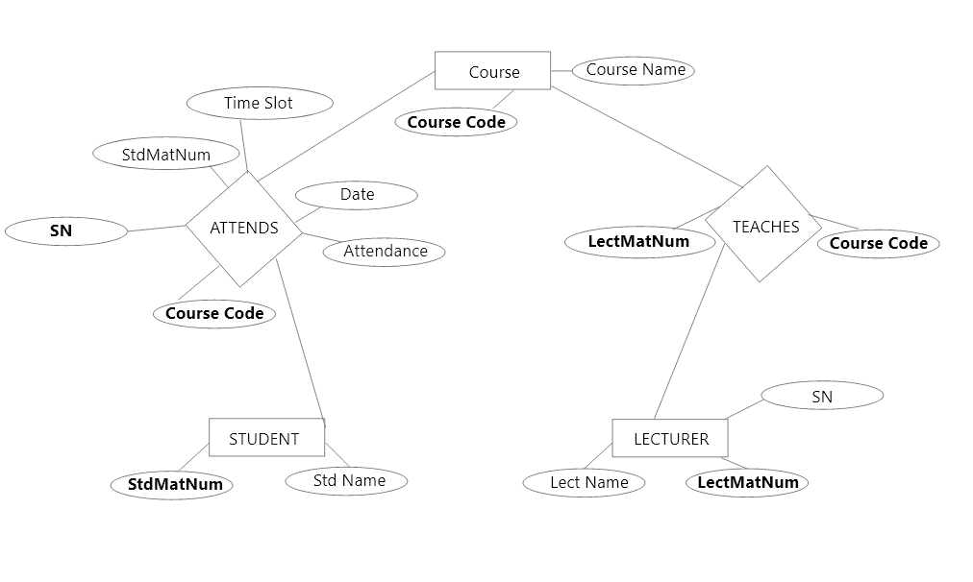

**Figure 1 Database ER diagra****m**

### Tables

Five tables have been used for the system. The tables are Student, Lecturer, Courses, Attends, and Teaches tables. The tables have been normalized before the implementation phase so as not to get redundancy.

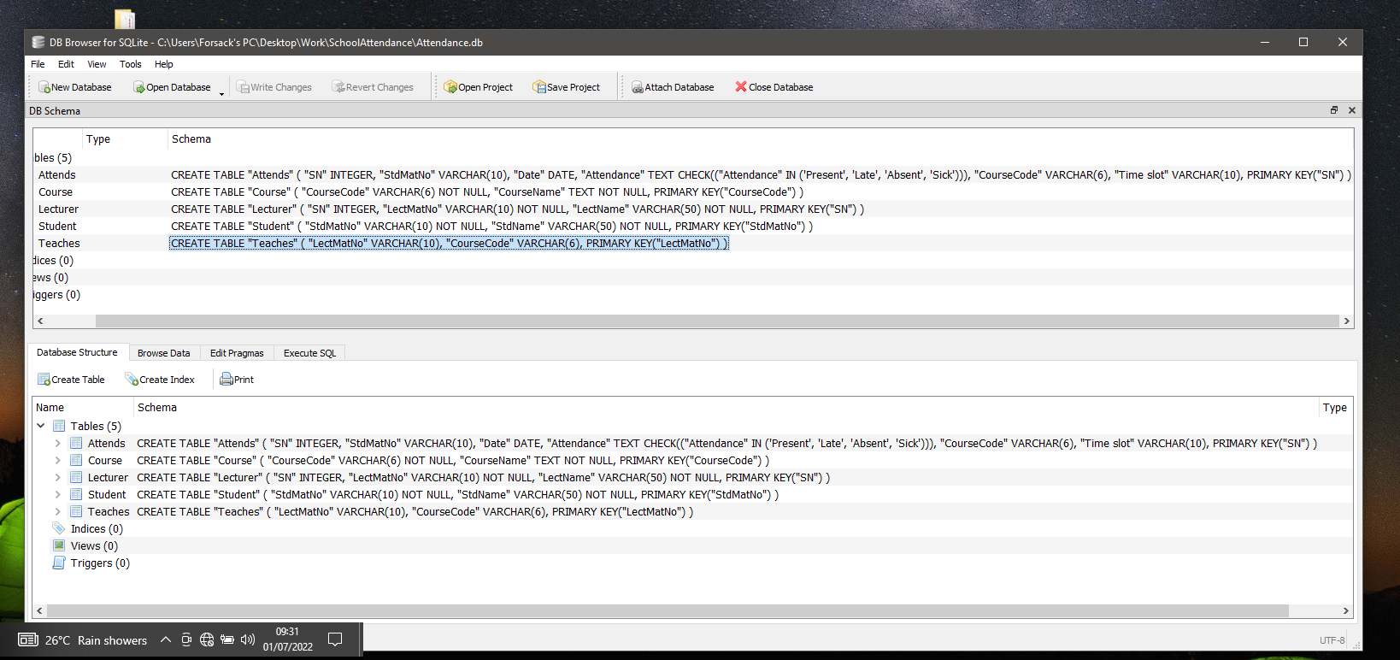

**Figure 2 Database Schema**

### Interface

The application is designed with the latest technology of user interface designs utilizing its simplicity and lightweight weighted layouts. The system uses Java Swing within it to increase the intuitive perceptions of the user.

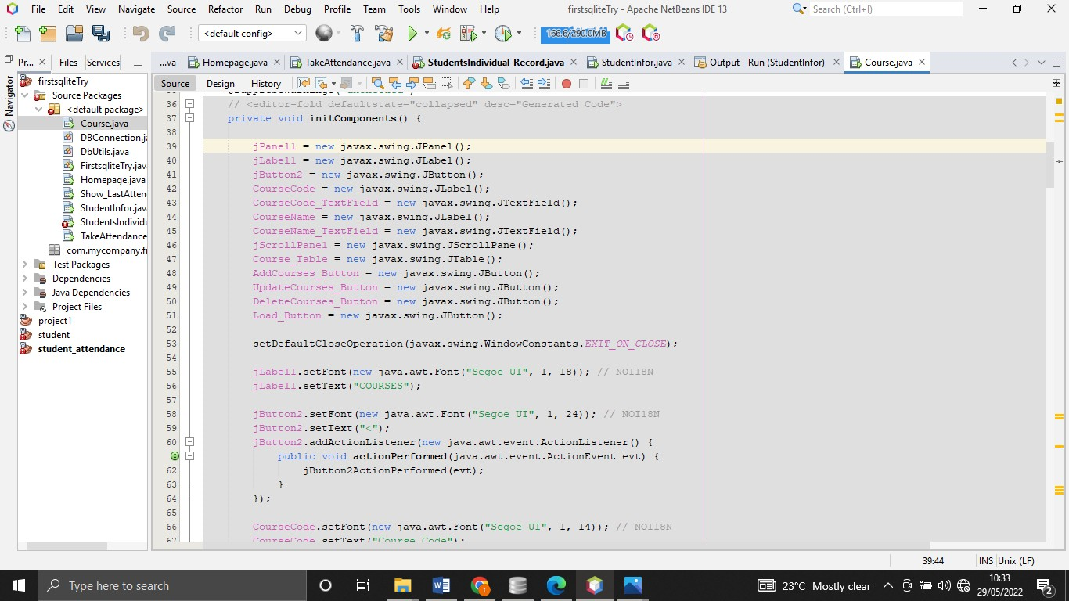

**Figure 3 *Snippet of Swing Components***

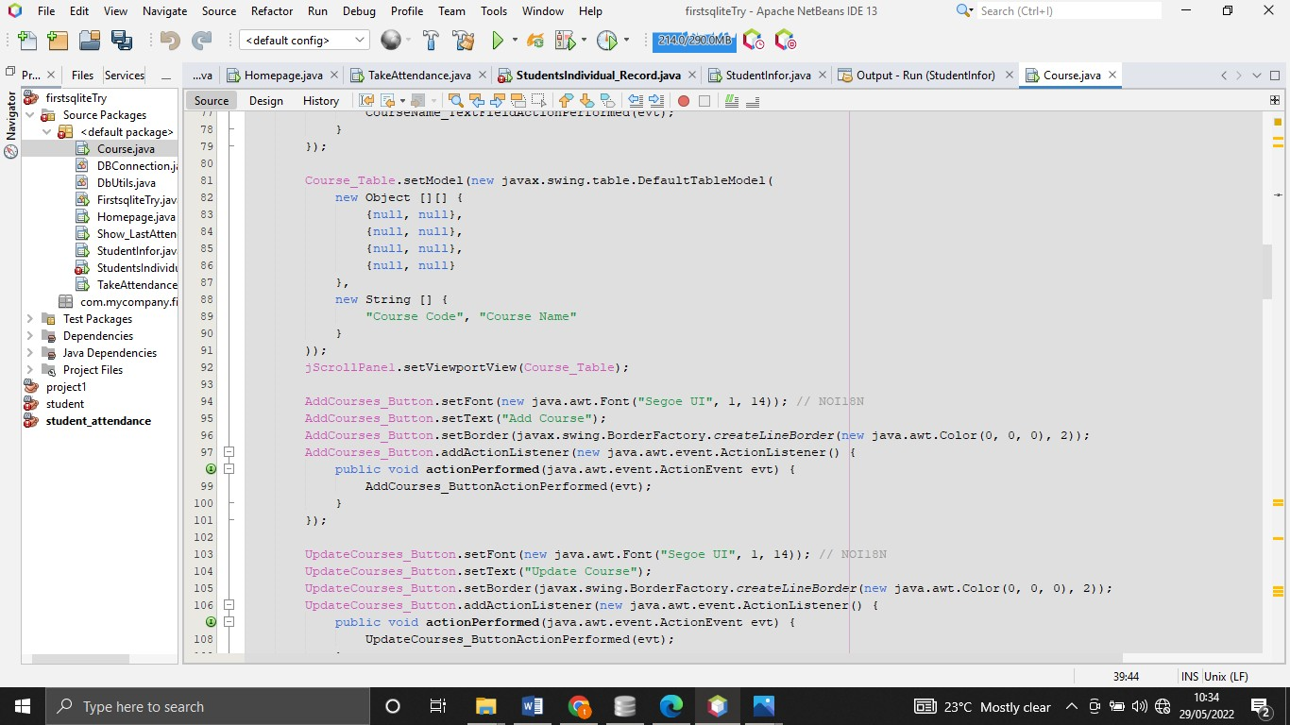

**Figure 4 Snippet of Swing Components**

### The core of the system

The system allows only one administrator which is the lecturer of a course. Which he or she will be able to add the data of students who are taking the course into the database. And s/he is allowed to take the attendance of the students present in the lesson and as a result, the system computes the eligibility criteria of the students. The types of the user include.

### Full Admin User (Lecturer)

This user has the privilege to register all the details of students taking his Course. This user has all the ability to add or drop a student and collect the attendance of his/her class in the system.

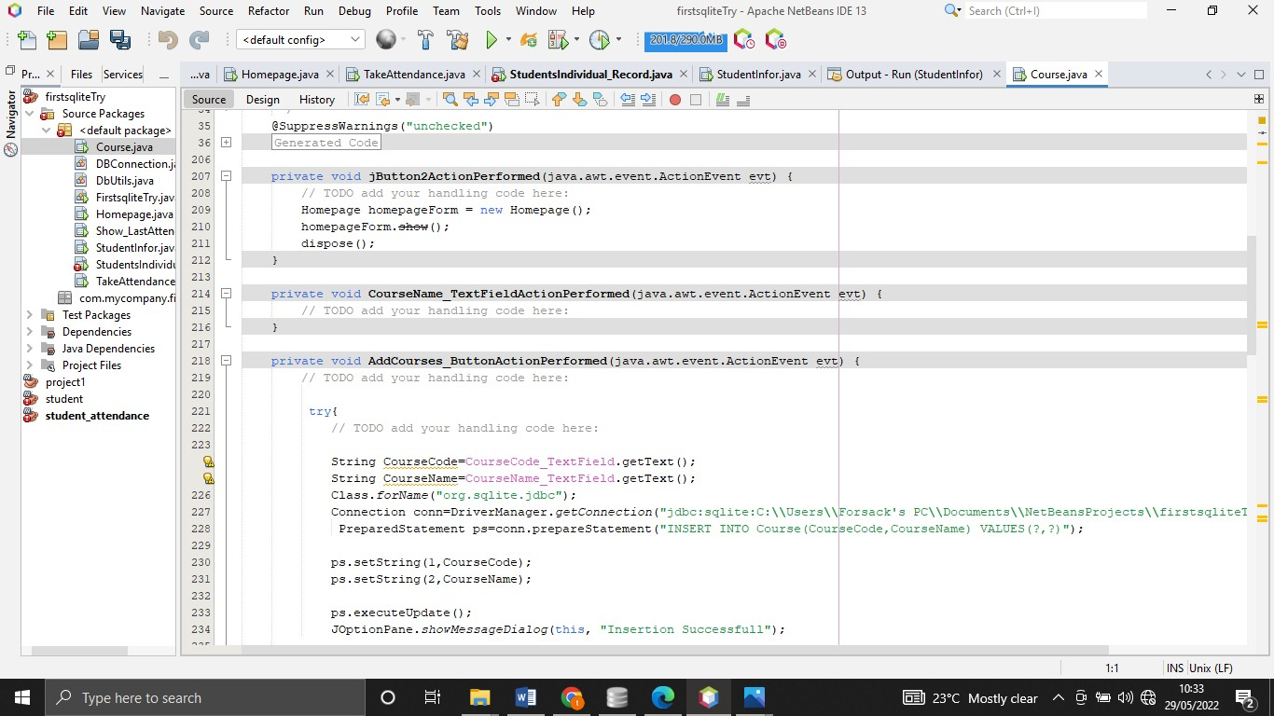

**Figure 5 Snippet of code**

# CHAPTER 4 RESULTS AND DISCUSSIONS

This chapter contains an overview of the broad area and a review of developmental technologies and platforms used in the development of the Computerized Attendance Management System.

The result of this research is an Attendance application, with a user-friendly GUI, which allows the user to take the attendance of students present in a particular class and as a result, get the total amount of time a particular student has been present in a particular class[4].

This helps save the time wasted by the lecturer in carrying out his attendance manually in class and counting the attendance of each student manually to get the attendance rate of a particular student in a particular course.

I started by surveying with course delegates and some lecturers of the department on how this attendance is being carried out and what this attendance is used for, I discovered that the attendance rate for a student is used to get if a particular student is eligible to sit-in for exams for a particular course and the lecturers count the number of times each student is present for his/her course to see if the student is eligible or not.

As a result, I know the type of data that is needed for this project. And I used this data to design my database.

In creating the database, I used the database client called SQLite Brower and used MySQL as the language.

I created multiple tables which help to relate the database and store all the data need for the computation of the attendance.

The language used for the development of the application is Java for the program logic and Java Swing for the graphical user interface (GUI). Where we utilized components such as JTextfields, JTables, JButtons, ComboBox, etc.

I imported some external libraries such as SQLite JDBC, JCalenda, RS2XML to add the functionality of the project.

To run the application after following the set-up guide found in the appendix, open your desired text editor and navigate to where the files are stored, then run the program. The screenshots of the interfaces are shown below;

### Homepage:

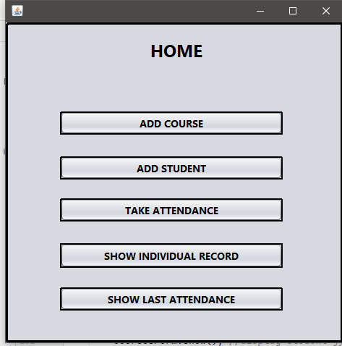

**Figure 6 Homepage**

### Courses:

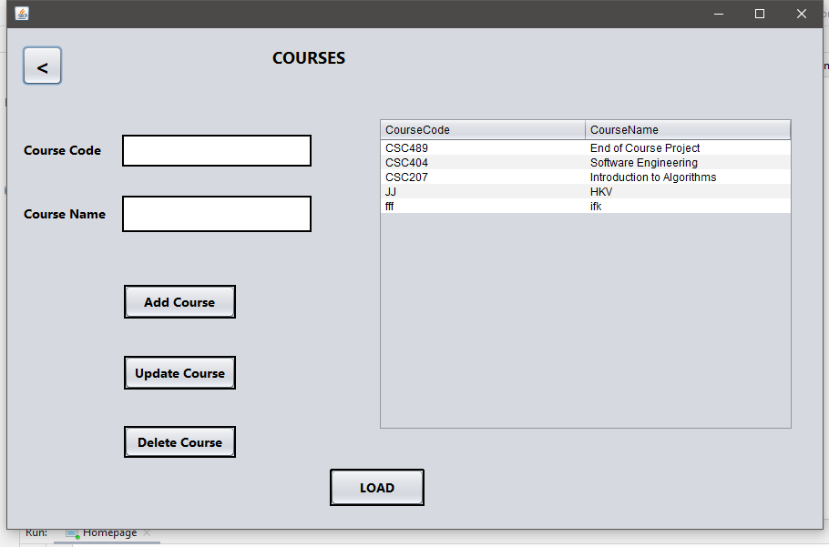

**Figure 7 UI of Couse page**

### Students:

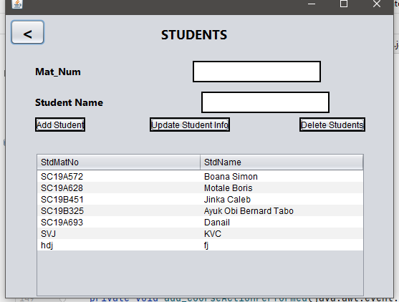

**Figure 8 UI of Student page**

### Show Last Attendance:

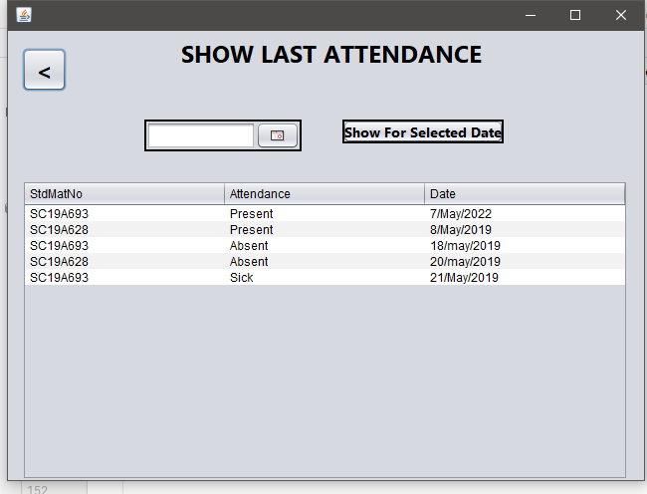

**Figure 9 UI of Last Attendance collected**

### Take Attendance:

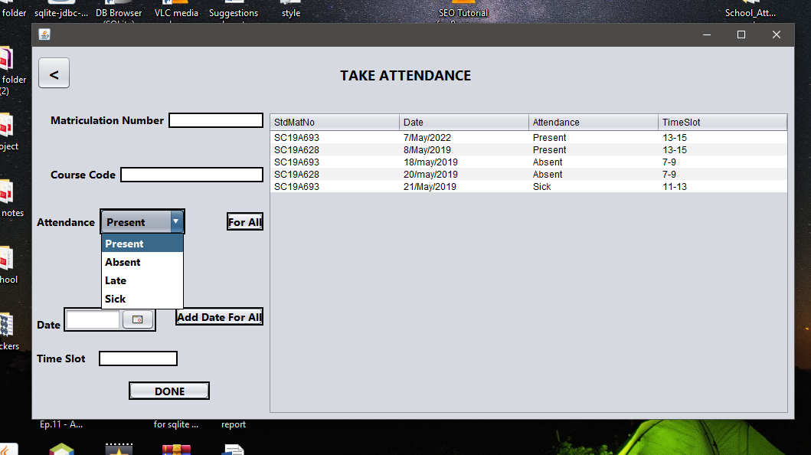

**Figure 10 UI of Taking Attendance page**

### Attendance Rate:

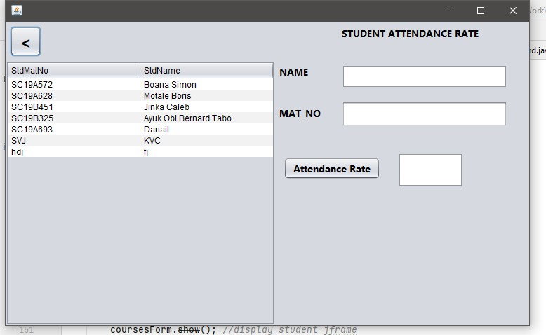

**Figure 11 : UI of Attendance Rate**

# CHAPTER 5

**SUMMARY/ CONCLUSION/RECOMMENDATIONS**

## SUMMARY

This project a desktop application for Attendance Management System is developed after reviewing and analyzing the existing manual system at the investigation stage. The design is implemented using Java Swing, SQLite for database, and Java for logic. The desktop application starts with the homepage where teachers can easily navigate the very user- friendly GUI to perform the desired action.

## CONCLUSION

The Attendance Management System is developed using Java and it fully meets the objectives of the system in which it has been developed. The system has reached a steady- state where all bugs have been eliminated. The system is operated at a high level of efficiency and all the teachers associated with the system will understand its advantage. The system solves the problems it was intended to solve.

## RECOMMENDATION

For the effective usage of this software and have good management of it, it is necessary to provide a computer to the vital registration centers and staff should be trained to acquire knowledge on how to use the computer and new system. So that the current system needs to be changed to meet global standards and the modern challenges of information technology.

# References

|  |  |
| --- | --- |
| [1] | S. MB, A web Enanbled Secure System for Atendance Monitoring and Real Time Location Tracking using Biometric and Radio Frequency Identification, Romil Roy: International Conference on Computer Communication and Information , 2015. |
| [2] | D. M. M. Ali, "Role of data mining in education Sector," *International Journal of Computer Science and Mobile Compuing ,* vol. 2, no. 4, 2013. |
| [3] | H. Zonggang, Design and implementation of student Attendance Management system, Zheng Junsheng: Neusoft Institude of Information Dalian, 2009. |
| [4] | H. &. M. I. &. A. E. Abdulkareem, Student Attendance Management System, i-manager's Journal on Information Technology, 2015. |

## Websites:

<http://wikipedia.com/> <http://www.w3schools.com/> <http://www.stackoverflow.com/>s <http://www.academia.edu/> <https://www.researchgate.net/>